Develop an app using Watson IoT Platform

Bluemix Lab Guide



Experience the power of IBM Bluemix  
Lab 1

*Activity 1: Create IoT App in Bluemix*

Lab 1: Create IoT App in Bluemix and build an App that sends commands to your phone.

In 60 or less minutes, you will build an app that will make your phone switch on/off the light each time you flip it.

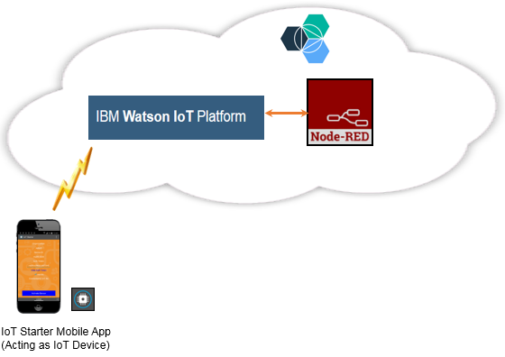

Below are the four activities we will complete in this lab exercise:

1. Create IoT App on Bluemix
2. Link IoT Starter App to Watson IoT Platform
3. Add Node-RED flow to IoT App

Activity 1: Create IoT App on Bluemix

In this activity, you will deploy a simple IoT application from the IBM Bluemix web interface.

1. In a browser, navigate to the following link:

* <https://bluemix.net> : This link takes you to your default location.

1. Click **LOG IN** and then enter your IBM id and password to sign in. You will see the following screen.

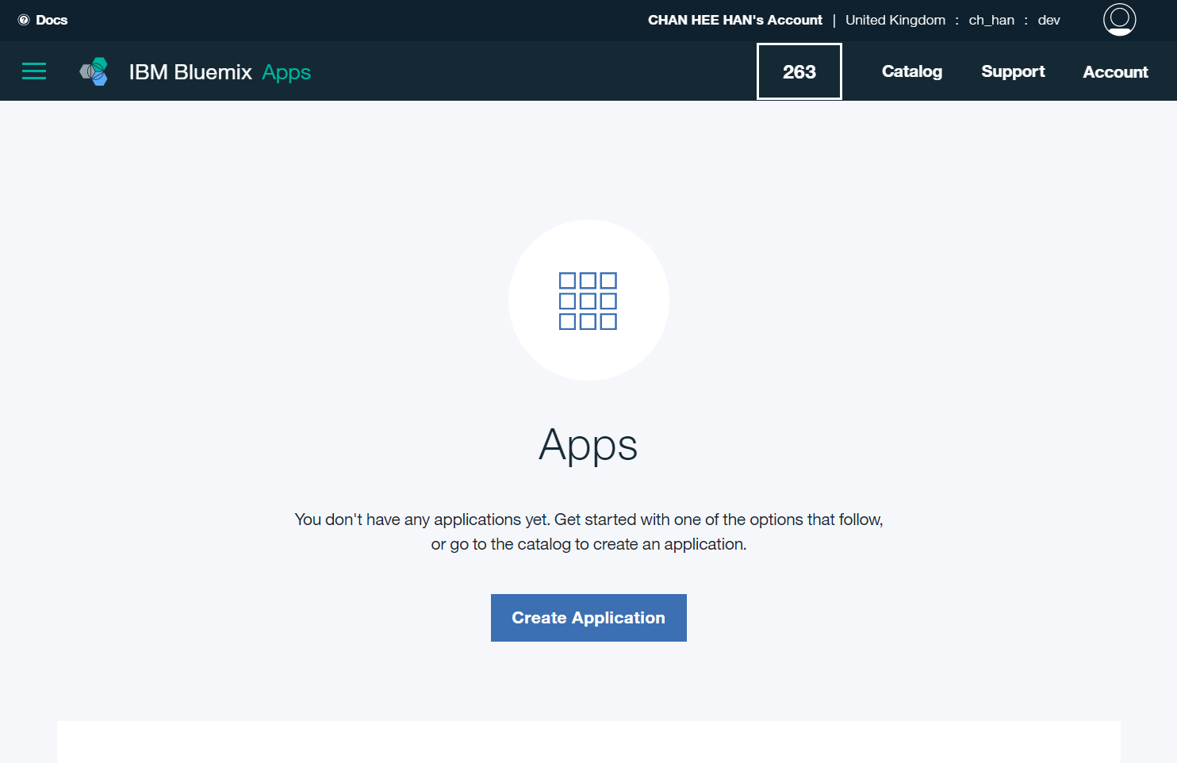

1. Click on the **CATALOG** in the top menu.

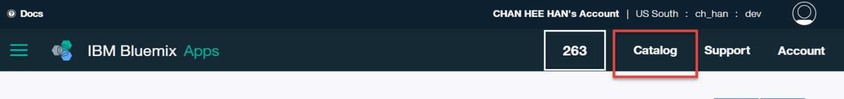

1. Select the **Internet of Things Platform Starter** from the **Boilerplates** section. A boilerplate is a container for an application and its associated runtime environment and predefined services for a particular domain. (Note: If you do not see this Starter, please ensure you are at the US South region – consult instructor for assistance if needed)

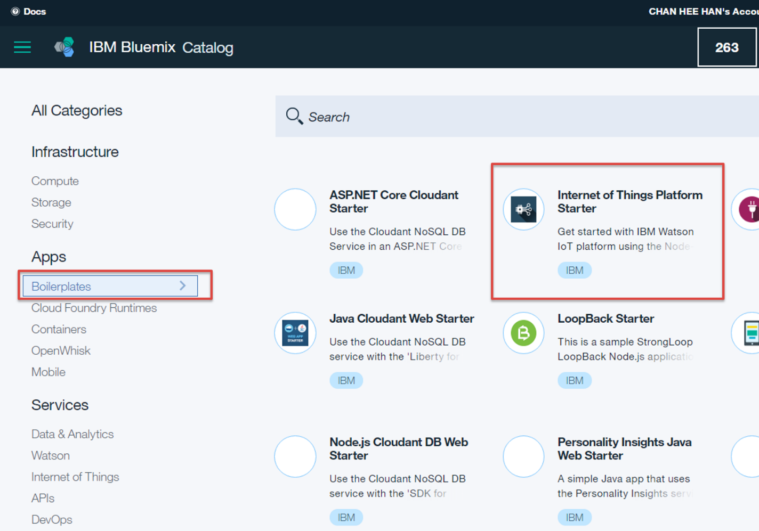

1. Enter a name for your application as shown below. The host name information is automatically entered. The host name must be unique on Bluemix, so enter a name with your company name or initials to make the name unique.

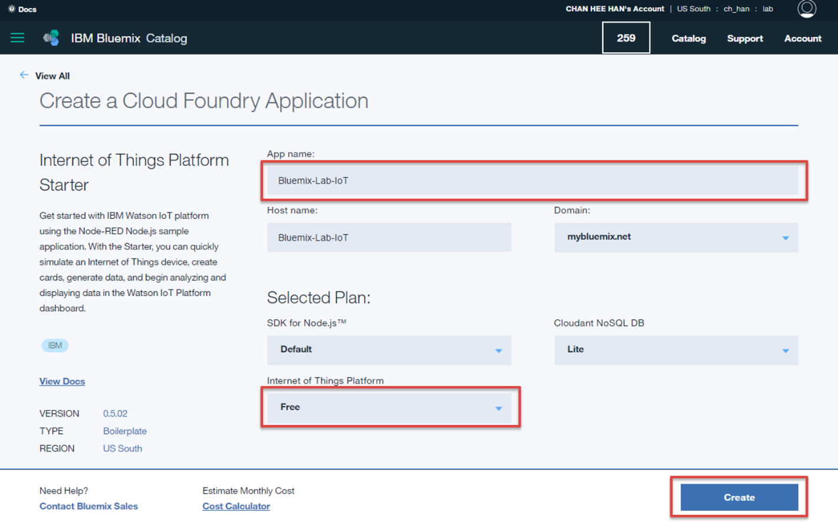

Wait for your application to stage until you see the green check next to your app name. This will take a while.

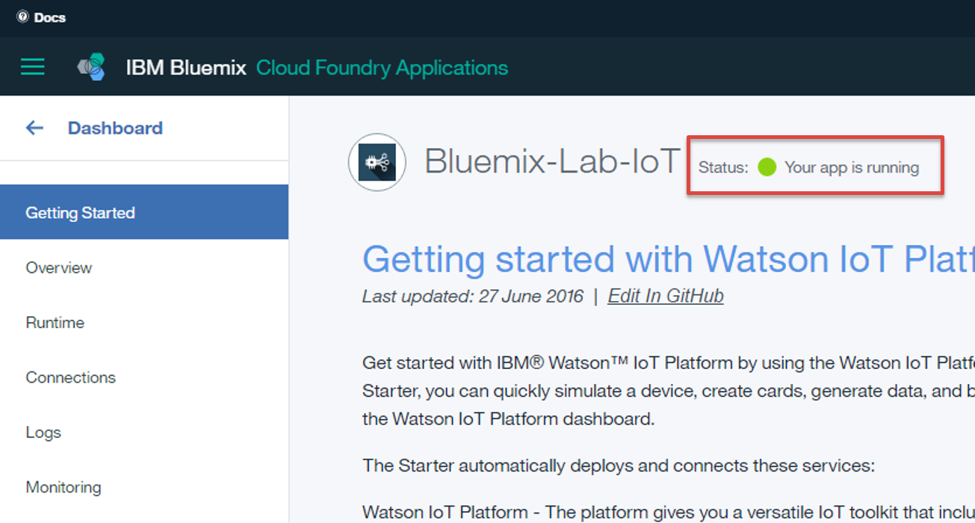

1. Click **Overview** tab.

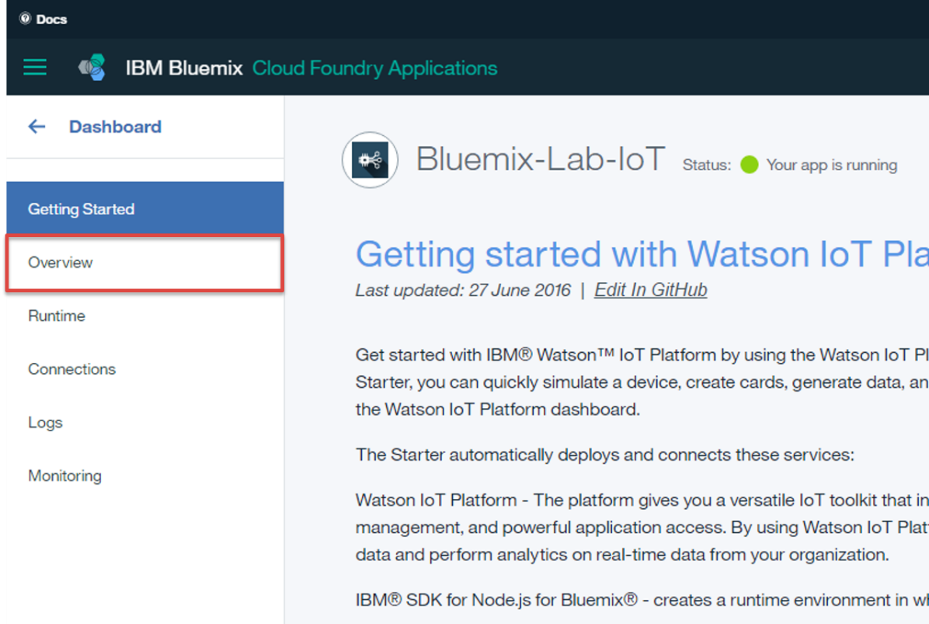

1. Click the **Internet of Things Platform service** in the **Connections** section.

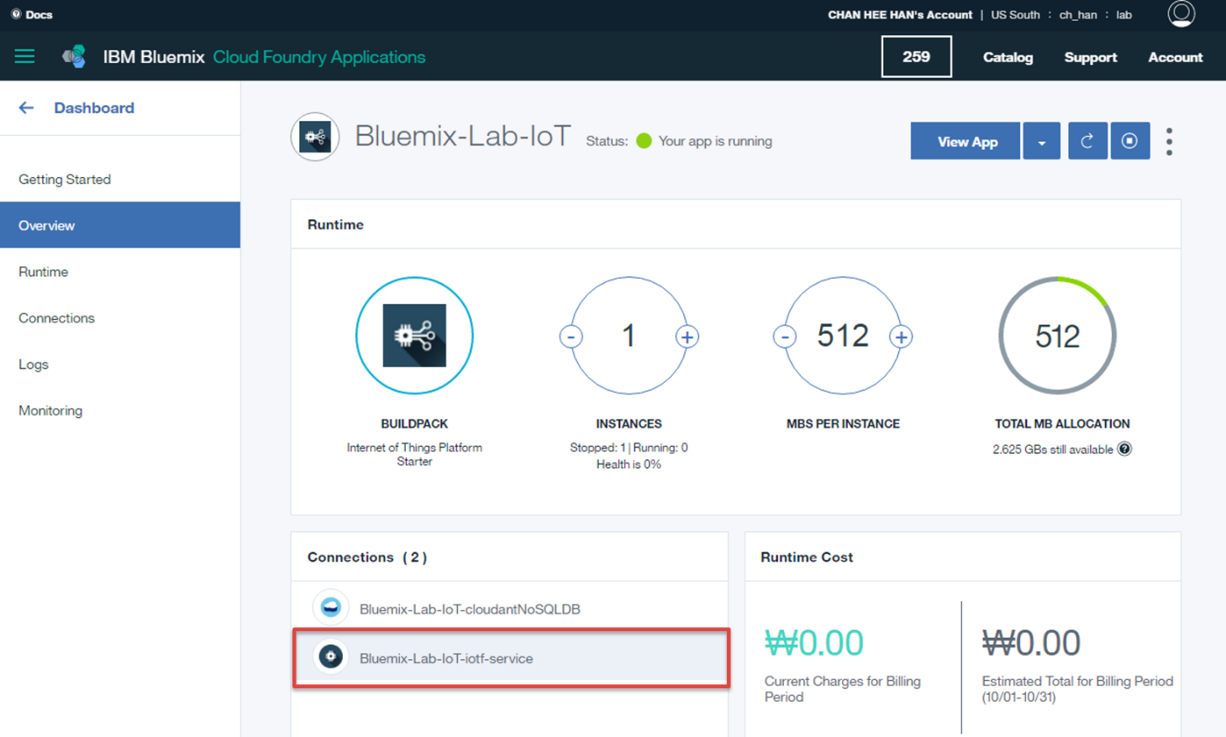

1. Click on **Launch dashboard**.

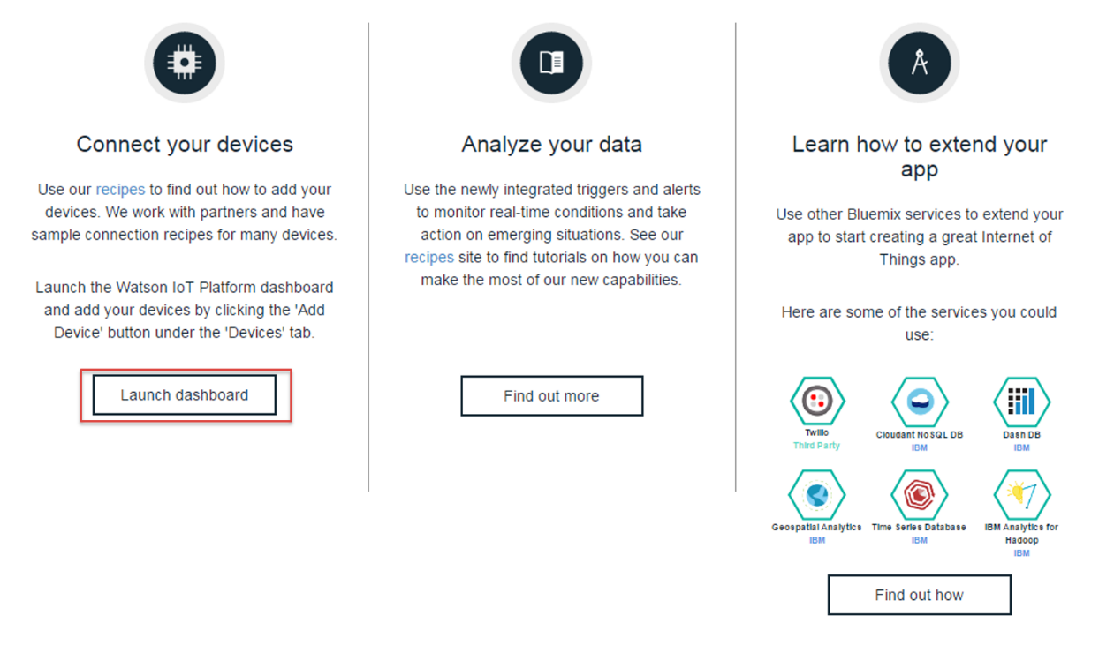

It will open your IBM Watson IoT Platform organization in a new browser tab.

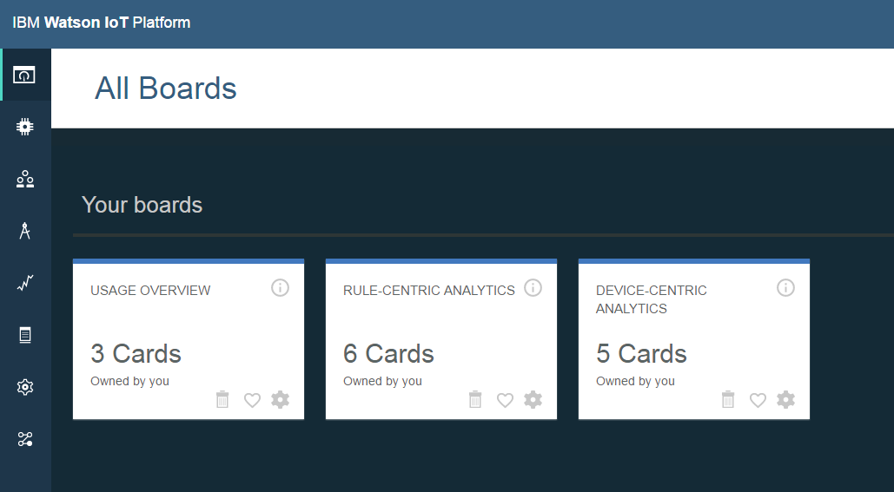

|  |
| --- |
| **What have you completed so far?** |

You have just quickly created an IoT App in Bluemix using Internet of Things Platform Starter boilerplate. This Starter automatically deploys and connects these services: 1) Watson IoT Platform 2) Node.js runtime for Node-RED 3) IBM Cloudant – a database in which Node-RED stores metadata.